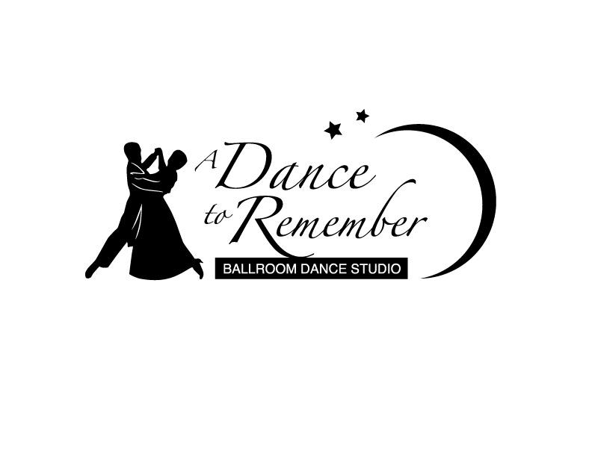

**811 Yellow Jacket Lane East, Rockwall, TX 75087**

[**www.ADanceToRememberTX.com**](http://www.ADanceToRememberTX.com)

**Group Class Schedule September 2015**

No Partner Needed. Couples and Singles Welcome!!!

**Cardio Ballroom: Mon and Fri, 9/4, 7, 11, 14, 18, 21, 25, 28, 12:00-12:45 p.m. $40 per month or $8 each**

**Intermediate Tap Dancing: Tue, 9/15, 22, 29, 12:00-12:50 p.m. $30 per month or $15 each**

**Intermediate Bronze Waltz: Wed, 9/2, 9, 16, 23, 30, 7:00-7:50 p.m. $50 per month or $15 each**

**Showcase Ballroom Medley: Wed, 9/2, 9, 16, 23, 30, 10/7, 14, 21, 8:00-8:50 p.m. In session**

**Intermediate Bronze East Coast Swing: Thu, 3, 10, 17, 24, 7:00-7:50 p.m. $40 per month or $15 each**

**Newcomer Ballroom Sampler: Thu, 9/3, 10, 17, 24, 8:00-8:50 p.m. $40 per month or $15 each**

**Country and Western: Fri, 9/4, 11, 25, 7:00-7:50 p.m. $30 per month or $15 each**

**Belly Dancing: Sat, 9/5, 12, 19, 26, 1:00-1:50 p.m. $40 per month or $15 each class**

**Carolina Shag: Sat, 9/5, 12, 19, 26, 2:00-2:50 p.m. $40 per month or $15 each**

**Tap Formation: Sat, 9/19, 26, 3:00-3:50 p.m. In session**

**Flamenco Formation: Sun, 9/6, 13, 20, 12:30-2:00 p.m. In session**

**ORLETA Folk Dancing Workshops: Sun, 9/6, 13, 20, 2:00-3:50 p.m. $60 per month**

Pre-registration for the classes is required. Please contact us prior to attending any group sessions. Thank you!

Saturday, September 12, 7-10 p.m. “Patriot Day” Studio Party ($10)

**Dancing, conversations and fun☺ Light refreshments will be served. Guests welcome!**

Friday, September 25, 8-10 “End of Summer” Last Friday Studio Dance ($6)

**Dancing and fellowship in a relaxed and friendly atmosphere! Guests welcome!**

Sunday, November 8, 2 p.m. Fifth Annual Fall Showcase @ Hella Shrine Temple

**Performances – Dinner – General Dancing! Tickets go on sale October 1st.**

**Private lessons by appointment**

**With questions or to purchase a Gift Certificate contact Margaret at** [**m.kochan.dance@gmail.com**](mailto:m.kochan.dance@gmail.com) **Cell 903-456-4717**

Thank you for your patronage! Schedule is subject to change.